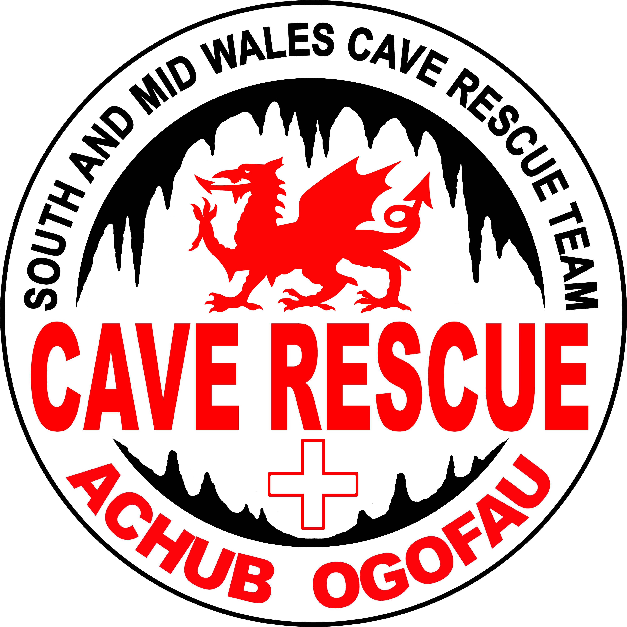

South & Mid Wales Cave Rescue Team
C/O SWCC Headquarters, No. 2 Powell Street, Penwyllt,
Pen-Y-Cae, Swansea, SA9 1GQ
Registered Charity No. 1016463

SMWCRT Membership Application

The purpose of this information sheet is to enable the team to construct an efficient callout list.
Please complete the form if you wish to be included on the South & Mid Wales Cave Rescue Team Callout List and to also be added to the Team's e-mail news list.
When you have completed and signed the form please place it in the pocket provided on the SMWCRT notice board at Penwyllt or Whitewalls, scan and email to secretary@smwcrt.org, or post to:

Sue Goodhead, SMWCRT Secretary, Lle'r Ysgaw, Parc Derw, Cradoc, Brecon, Powys. LD3 9QA

Name |  |  | DOB ____ / ____ / _____
Email
Address
 |  | Postcode
Home phone | Work Phone | Mobile

Full Membership
Full Members wish to be called out for Cave Rescues, either in Underground or Surface Roles.

Associate Members
Associate Members wish to support the Team, but do not wish to be called out for Cave Rescues. Associate members may receive communications from the Team and invitations to fund raising events and public occasions.

Do you wish to be a Full Member of SMWCRT or an Associate Member? ____________________

Proposer
In order for SMWCRT to consider your application, it will be helpful for you to nominate a Proposer who can recommend you to the Team. The Proposer should be able to comment on your suitability for either underground, surface, or surface support duties as a prospective Cave Rescuer. Examples of suitable Proposers would be a member of a Cave or Mountain Rescue Team, a Caving Club representative, an experienced Caver known to SMWCRT, or anyone else you believe can comment on your suitability.

Proposer Name: | Capacity in which proposing:
Proposer Email: | Proposer Contact Number:
Please turn over and complete other side
Rescue Availability (tick one option):
Every Day | Weekends | Worth a Try
Approximate Number of Caving Trips per Year:

Estimated Travel Time to (mins):
Penwyllt | Llangattock | Welshpool
Cinderford (Forest of Dean)

Would you prefer a Surface or Underground Role?

Searches for lost or overdue parties are common. How well do you know the following caves?
To help us form efficient search teams please grade your knowledge on a scale of 1-5.

1–Entrance and entrance series. 2-Novice trip areas. 3–Main trade routes. 4–Trade routes and less visited areas. 5–Know the cave very well. Please score for each.

Agen Allwedd |  | Dan yr Ogof |  | Daren Cilau
Ogof Draenen |  | Ogof Ffynnon Ddu |  | Craig y Ffynnon

Other Caves you know? (Please grade as above)

Do you have any special skills or qualifications that would be useful in cave rescue?
Please answer Y/N below.

Advanced First Aid Certificate |  | Basic First Aid Certificate |  | Off Road Driving
Pitch Rigging/Hauling |  | Cave Diving |  | Communications
Competent at SRT |  | Rescue Control |  | Digging/Shoring
Surface Navigation |  | Explosives License |  | Other

I agree that the information provided will be kept on the SMWCRT electronic database for use ONLY in identifying Cave Rescuers, for assistance in searching wilderness areas on Cave Rescue callouts and to keep all Team members informed of relevant news and events. The information will not be communicated to any other person or body.

Signed __________________________________________ Date ________________

Thank you for completing and returning this questionnaire.

